**Student ID:** ______________________________________________

**Full Names:** _____________________________________________

Software Engineering

(CS425)

(June 2019)

Professor: O. Kalu

Final Integration Exercise

1. The exam duration is 2 hours.
2. The exam is computer-based; so you may use a computer for both the coding and theory parts.
3. Make sure to switch-off your cell-phones or simply turn the ringer off.
4. **This exam is a copyrighted material and must not be copied or reproduced or transferred or shared or distributed**.
5. You are expected to use an IDE or any Code Editor tool of your choice to implement your solutions for the questions in the Coding part.
6. Upon completion, put your project(s), **(source code only)** in a single zip file named **FinalExam.zip**, including your completed/finished exam paper (i.e. this document – **in Microsoft Word or PDF format, only**), and submit to Sakai.

--------------------------------------------------------------------------------------------------------------------

Type your answers to the theory questions in the following pages.

--------------------------------------------------------------------------------------------------------------------

(CS425 - SWE)

(June 2019)

Final Examination (80 points)

**Part I – Theory (True/False, Short answers, Multiple-choice questions):** (20 points)

1. (2 points) **Science of Consciousness**:

Answer the following question by giving 2 sentences in support of your answer:

From your understanding of Unit Testing versus Integration Testing, write two (2) sentences that provide a correlation between these two aspects of software testing, with the Science of Consciousness principle that states that, “the Whole is greater than the sum of its Parts”.

1. (6 points) Answer the following questions with True or False.
   1. (2 points) In the Rational Unified Process model for Software development, Architecture analysis is first performed before the Use-case analysis activities.

True or False?

________ _____________

* 1. (2 points) In a software development project where the Agile methodology is applied, the software requirement features are developed in small, incremental steps which are completed through multiple iterations, resulting in frequent updated releases of the software product.

True or False?

___________ ____________

* 1. (2 points) In the RUP process model, during the Architecture Design activity, the class coded below will be globally visible to all other classes across the system.

True or False?

__________________ ______________________

**package** edu.mum.cs.cs425.prodmgmt.global.publicc;

**class** GlobalPublicUtils {

**public** **static** **final** **long** ***MAX_INVENTORY_COUNT*** = 10000L;

// **TODO**

}

1. (12 points) Give short answers to the following questions.
   1. (6 points) Explain the meaning of each of the following 3 JPA annotations. (For each, give examples to illustrate your answer).
      1. **@Column**(name="product_number", nullable=false) private long productNumber;
      2. **@NotNull** private long productNumber;
      3. **@NotBlank** private long productNumber;
   2. (2 points) With respect to relationship between two classes/entities, what do we mean by the term, Dependency. Give an example using code snippets and/or diagram.
   3. (2 points) With respect to relationship between classes/entities, what do we mean by the term, Composition? And how does it differ from an Aggregation? Give examples to illustrate your answer.
   4. (2 points) In the Agile methodology, as practiced at Microsoft, what is ATDD?

**Part II – Software Engineering Problem-solving, Coding skills:** (60 points)

**Note:** *For the tasks in this question, you are expected to take screenshot(s) of your result(s), save each into a .png or .jpg image file(s) and include these in the FinalExam.zip file, you submit. From your own solution, you are required to take each of the set of 6 evidential sample screenshots, which have been included below.*

1. (60 points) **Implementing an end-to-end, full-stack data-driven web application**

A popular city hospital, named HolyCross Medical Center (HCMC), has hired you to design and develop a simple web-based software solution for them, which they will be using to run part of their hospital operations. Specifically, the system will be used in collecting and managing data about their **Patient**s. They want you to implement a basic web application for this purpose. Especially important to the Chief Medical Director of HCMC is, the data that provides information about their Elderly Patients.

An Elderly Patient is any patient who is of age, 65 or older.

Here are the attributes and sample data for the Patient entity:

**Patient**:

patientId:long, (Primary Key)

patientNumber, (e.g. P1000001, EP1000002, EP1000003 etc.)

isAnOutPatient: (values: “Yes” or “No”)

fullNames, (e.g. John H. Smith, Ann-Marie Washington, Diego A. Ortiz etc.)

emailAddress, (e.g. [jhsmith@globalmail.net](mailto:jhsmith@globalmail.net), [awashington@hcmc.org](mailto:awashington@hcmc.org), etc.)

contactPhoneNumber, (e.g. (641) 001-0012, (641) 002-0034, etc.)

dateOfBirth, (e.g. 1959-5-21, 1949-12-3, etc.)

For this question, you are required to do the following:

Using the set of tools, technologies and frameworks which you have learnt about in this CS425-Software Engineering course, including Spring Boot, Spring Web MVC, Spring Data JPA, etc., (or some other Enterprise Web application development platform/tool(s) that you prefer), implement a working web application for HCMC. You may use any database of your choice.

You are expected to implement only the following features and use-cases:

1. Display a homepage which presents a set of menu options.
2. Display list of Patients (Allows the user to view a list of all the Patients registered in the system). The hospital requires this list to be displayed sorted in ascending order of the Patients’ fullnames (see sample screen below).
3. Register a new Patient (Allows the user to add a new Patient into the system).
4. Display list of Elderly Patients (Allows the user to view a list of only the Elderly Patients who are registered in the system). The hospital requires this list to be displayed sorted in order, from the oldest Elderly Patient to the youngest Elderly Patient (see sample screen below).

Shown below are sample User Interfaces for the use-cases/features.

**Note:** Your own UI design does NOT necessarily have to look exactly like these samples. But your UIs should contain all the necessary data and data fields, as shown.

**Homepage:**

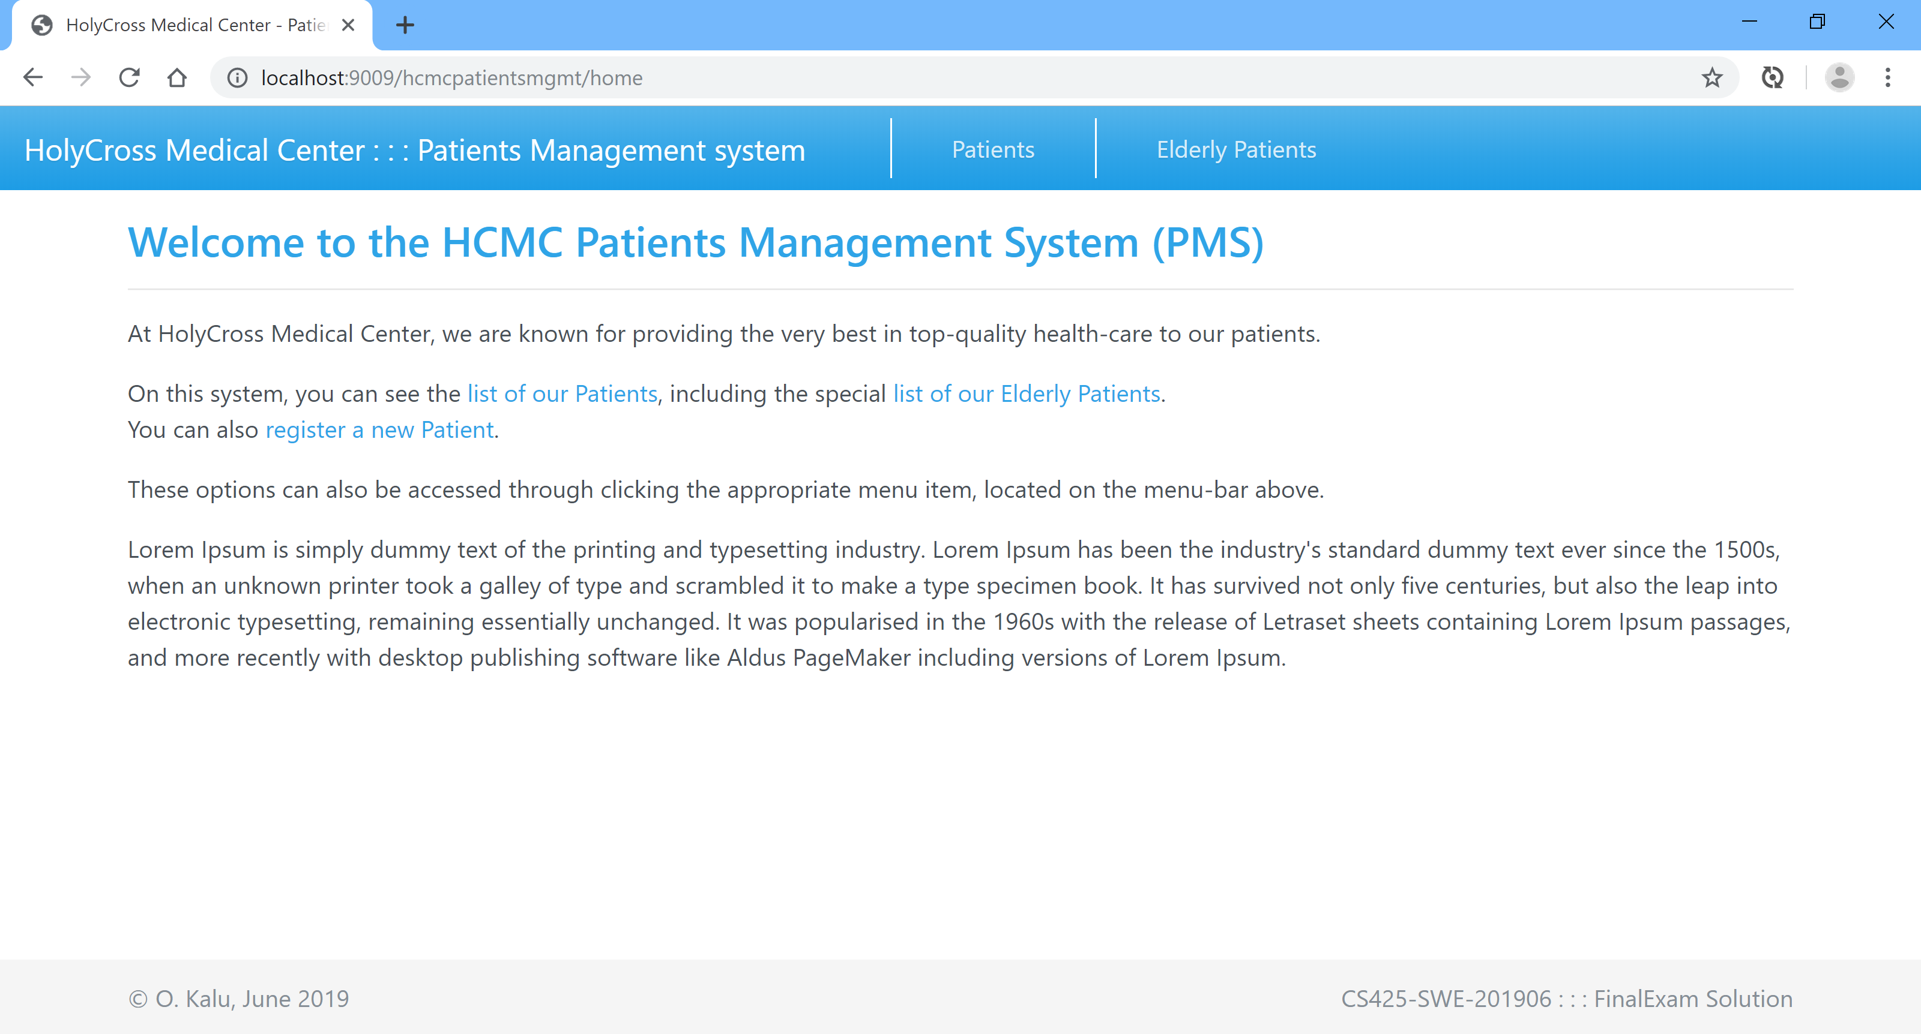

**List of all Registered Patients (note: Sorted by their Full Names):**

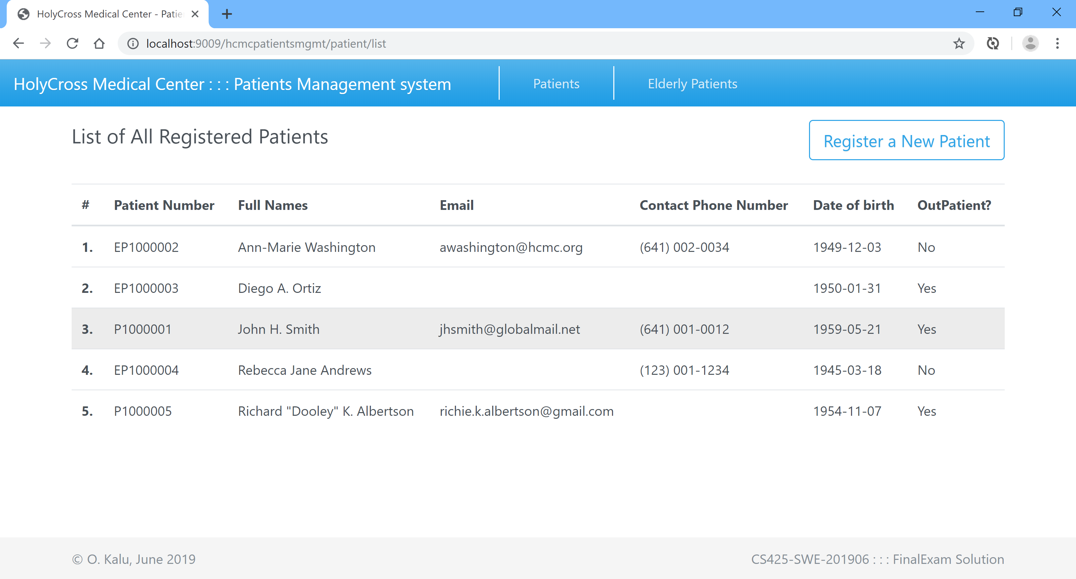

**Add/Register a new Patient:**

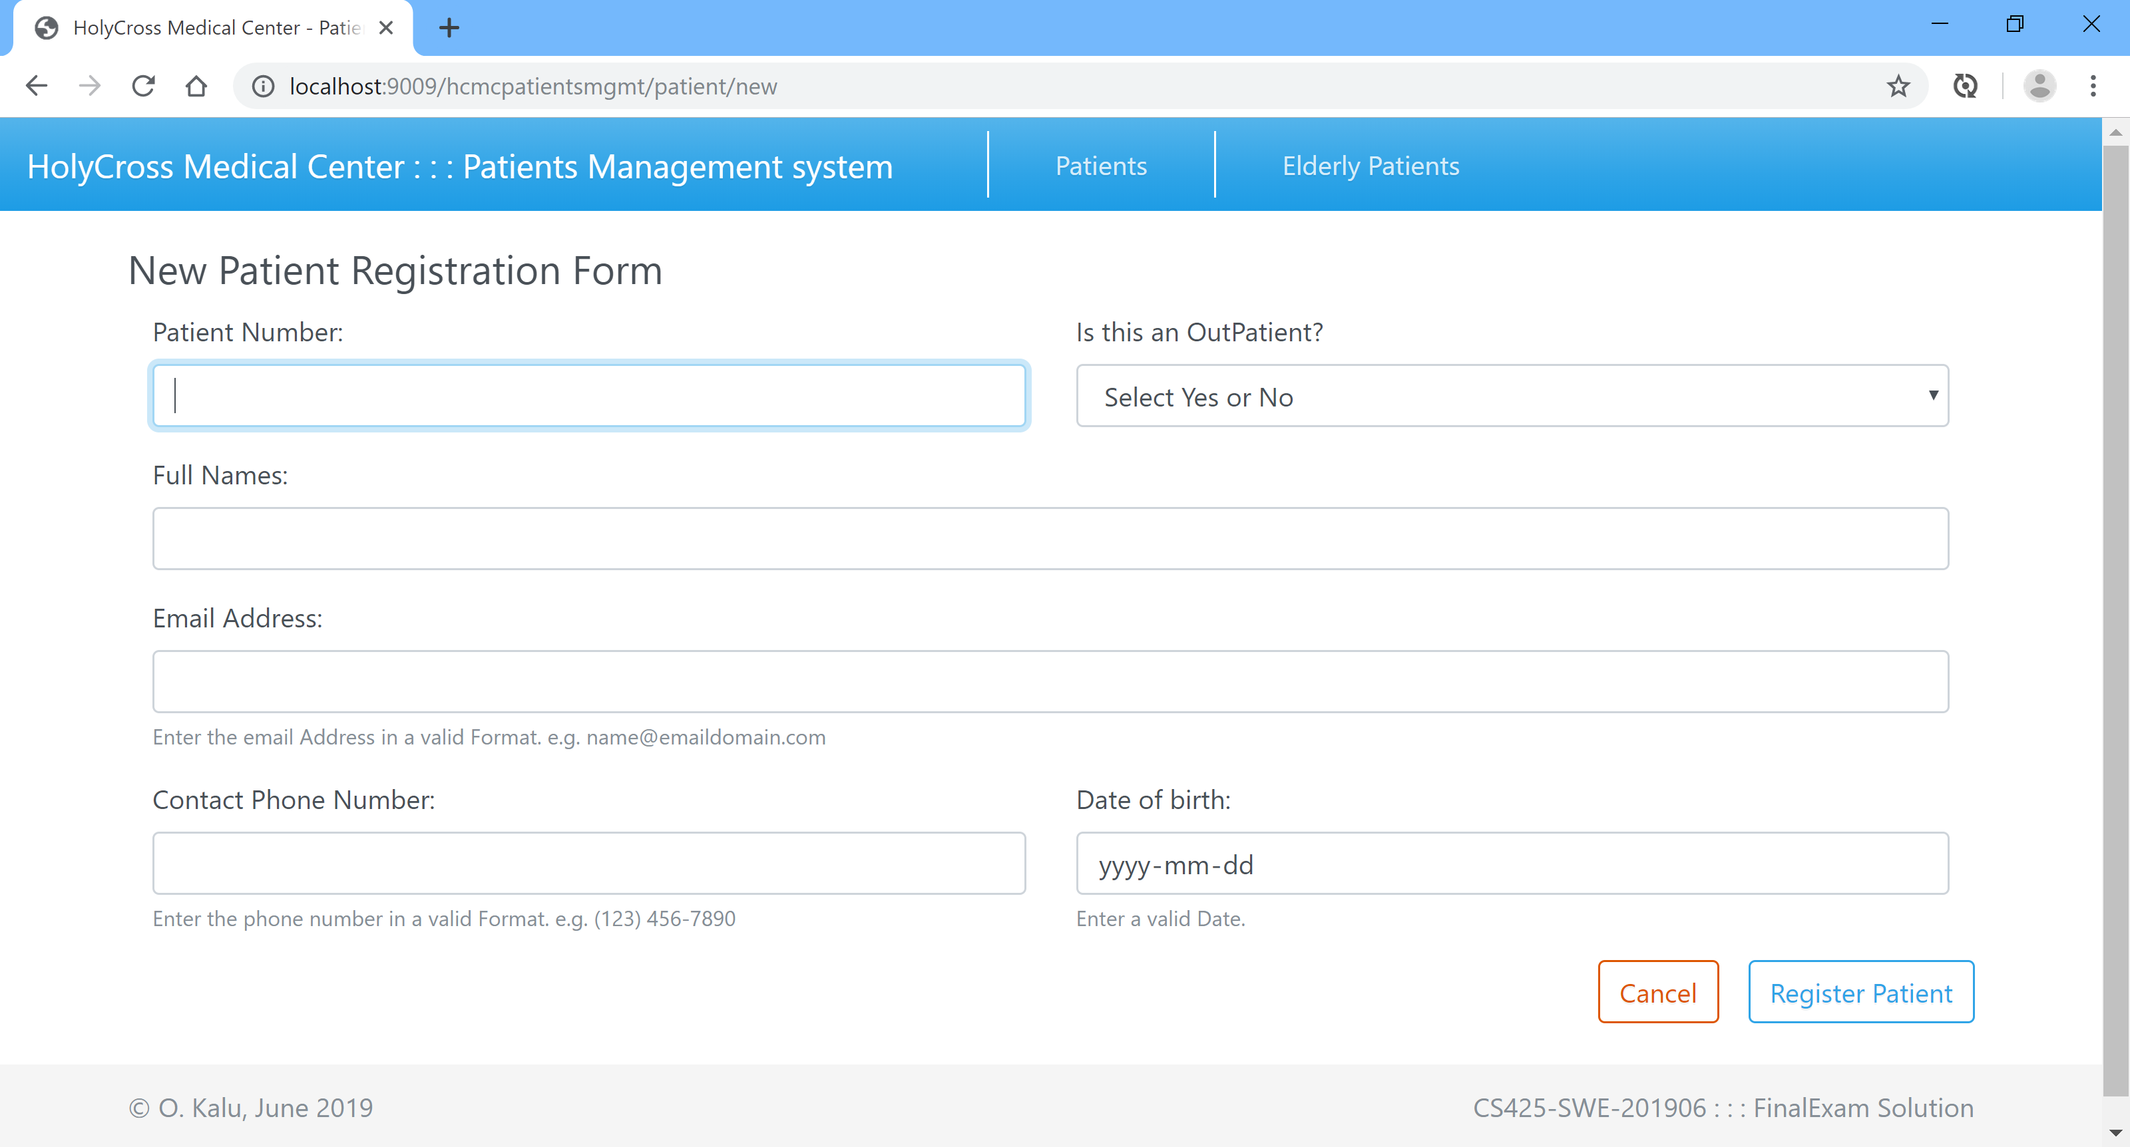

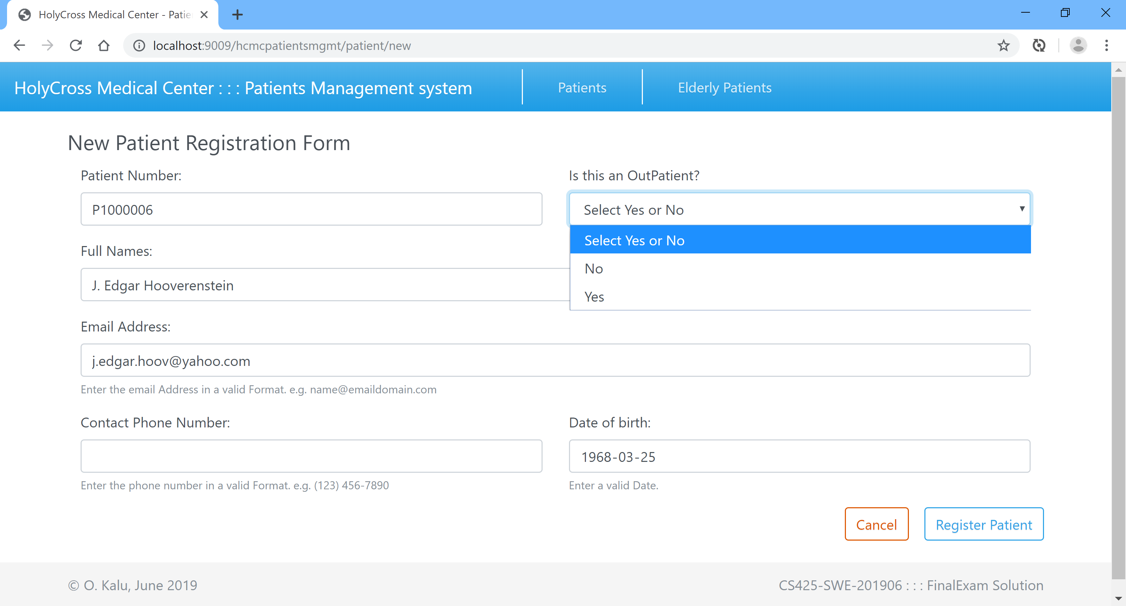

**List of Elderly Patients**

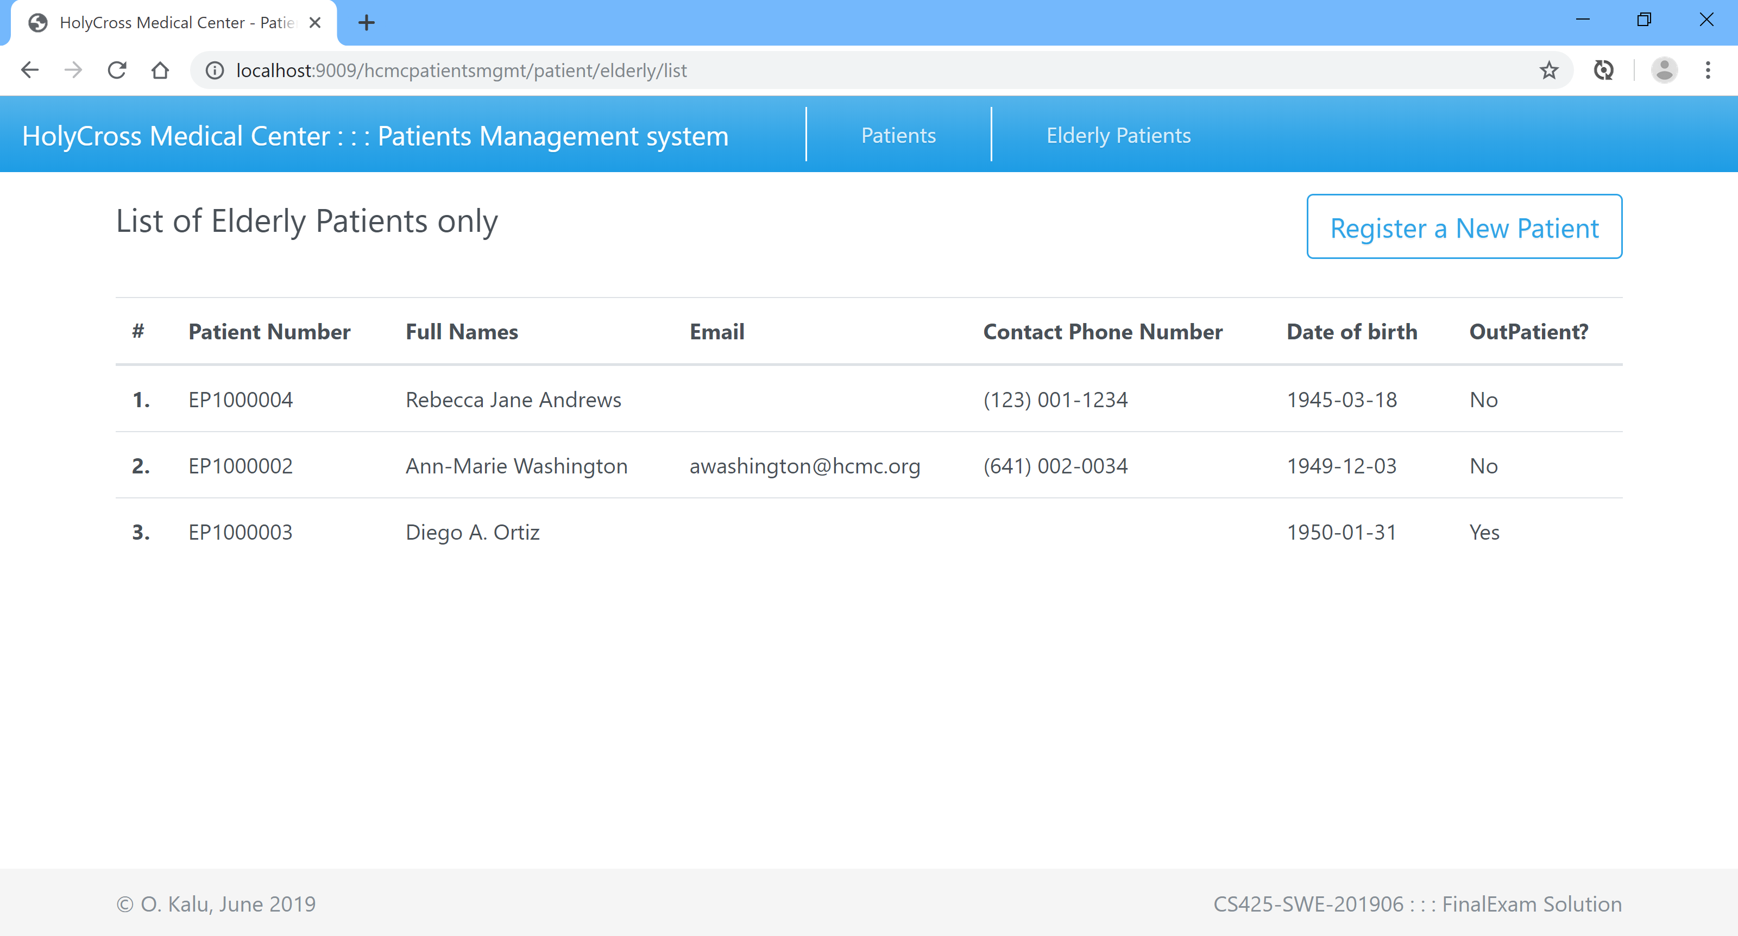

**Database Tables screenshots:**

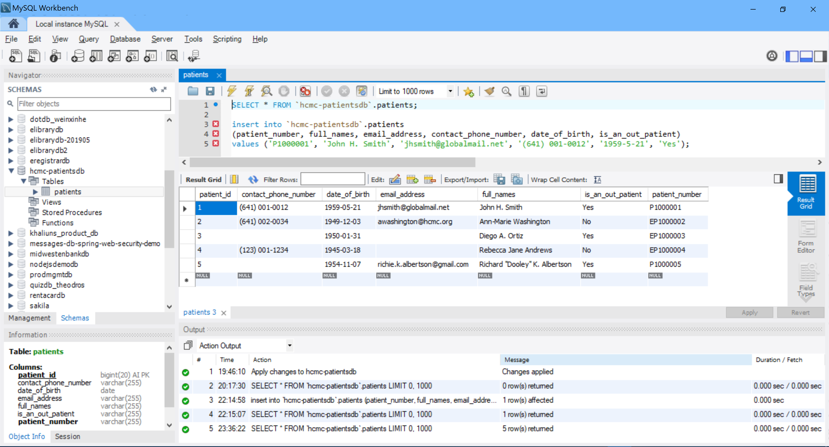

**//-- The End --//**